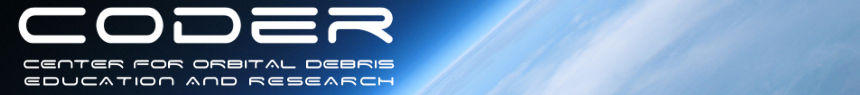
2018

CALL FOR ABSTRACTS

2018 WORKSHOP ON ORBITAL DEBRIS EDUCATION AND RESEARCH

The UMD Center for Orbital Debris Education and Research announces a call for abstracts for CODER2018. The Fall 2018 CODER Workshop will be a premier networking activity and forum for orbital debris issues and ideas, open to all who are involved or interested in any aspect of the growing threat to safe and secure space flight. The workshop will be held at The Hotel at the University of Maryland, College Park. Travel and accommodation information can be found here.

WORKSHOP SCOPE
Six keynotes and twelve panel sessions will take place over the three-day event. Abstracts are sought in all fields supporting the orbital debris enterprise, including, but not limited to:

- Space Situational Awareness
  - Detection, Tracking, Identification, & Characterization (DTIC)
  - Behavior Quantification, Assessment, & Prediction
  - Space Object and Event Ontologies, Taxonomies, and Models
  - Multi-Source Information Fusion Models & Methods
  - Evidence & Decision Support Systems
- The Space Environment
  - Monitoring
  - Flux Prediction & Evolution
  - Space Weather & Atmos. Models
- Mitigation Practices and Technologies
  - Hypervelocity Impacts / Shielding
  - Passivation/EOL Disposal
  - Mission Design
- Remediation Technologies & Architectures
  - Rendezvous/Docking/Autonomy
  - Sensors
  - Capture Devices
  - Deorbit Technologies
- Space Policy
  - SSA Information Sharing
  - Space Traffic Management
  - Mitigation/Remediation Policy
  - International Collaboration
  - Re-entry Liability

For information on the past workshops (CODER 2014/2016), please go to the Workshops tab here.

ABSTRACT SUBMISSION
Please submit abstracts in the following informal format:
Identify title, author, affiliation and contact information. Submit a one-paragraph abstract of no more than 500 words, and a brief biography highlighting your relevant experience. Abstracts should be emailed to coder-admin@umd.edu. The workshop will be presentation only. No papers will be required.

Submission/Registration Schedule:
- Abstract Submission Deadline for Best Consideration: September 14
- Notification of acceptance to Authors October 1
- Early Bird Registration Deadline October 15
- Deadline for Presentation Submissions November 1
- Workshop November 13-15

VENDORS / SPONSORS
Companies wishing to set up a booth at the workshop or sponsor a workshop event can find sponsorship opportunity information at http://www.coder.umd.edu/workshop/sponsors.

Please email us at coder-admin@umd.edu if you have questions about any aspect of the workshop. For more information refer to the CODER2018 website (http://www.coder.umd.edu/coder2018)

